

Virtual Private Cloud (VPC)

What is Virtual Private Cloud?

- “Amazon Virtual Private Cloud (Amazon VPC) enables you to launch Amazon Web Services (AWS) resources into a virtual network that you’ve defined. This virtual network closely resembles a traditional network that you’d operate in your own datacenter, with the benefits of using the scalable infrastructure of AWS” – Amazon Web Services

- A VPC Resembles On-Premise:

  - Private data centers

  - Private corporate network

- Private Network

  - Private and Public subnets

  - Scalable architecture

  - Ability to extend corporate/ on-premise network to the cloud as if it was part of your network (VPN )

Benefits of a Virtual Private Cloud

- Benefits of a Virtual Private Cloud

  - Ability to launch instances into a subnet

  - Ability to define custom CIDR (IP address range) inside each subnet

  - Ability to configure route tables between subnets

  - Ability to configure internet gateways and attach them to subnets

  - Ability to create a layered network of resources

  - More security settings to protect cloud as sets

  - Extend your network into the cloud with VPN / VPG and an IPsec VPN tunnel

- Layered Security

  - Instance Security Groups

  - Subnet network ACLs (Essentially a firewall for incoming packets on the subnet level)

Understanding The Default VPC

Understanding The Default VPC

- Default VPC is a different setup than a non-default VPCs

- Default VPC is meant to allow the user easy access to a VPC without having to configure it from scratch

- In the Default VPC all provided with the Default VPC have an internet gateway attached

- Each instance added has a default private and public IP address (defined on the subnet settings ), remember public IP addresses are attached/ routed to an ENI that has a private IP address attached to an instance (NAT).

VPC Peering

- VPC Peering

  - VPC Peering enables the ability to create a direct network route between one VPC and another. This allows the s haring of resources between two subnets as if it was on the same network. Basically, at a high level it creates a link between the two.

  - VPC Peering can occur between other AWS accounts and other VPCs within the same region

  - VPC Peering connections cannot occur between two regions

- Scenarios

  - Peering two VPCs – Company runs multiple AWS accounts and you need to link all the resources as if they were all under one private network (assuming resources in the same region)

  - Peering To A VPC – Multiple VPCs can connect to a central VPC but cannot communicate with each other, only communication can occur between the peered VPC and the primary. This use case could be if a third party was s haring a resource that the customers needed to connect to. (File sharing, Customer Access, Active Directory)

VPC Limits

VPC Limits

- 5 VPCs per region (more available upon request)

- 5 internet gateways (this is equal to your VPC limit because you only have on internet gateway per VPC)

- 50 customer gateways per region

- 50 VPN connections per region

- 200 route tables per region / 50 entries per route table

- 5 elastic IP addresses

- 500 security groups per VPC

- 50 rules per security group

- 5 Security groups per network interface (remember security groups are on the VPC level)

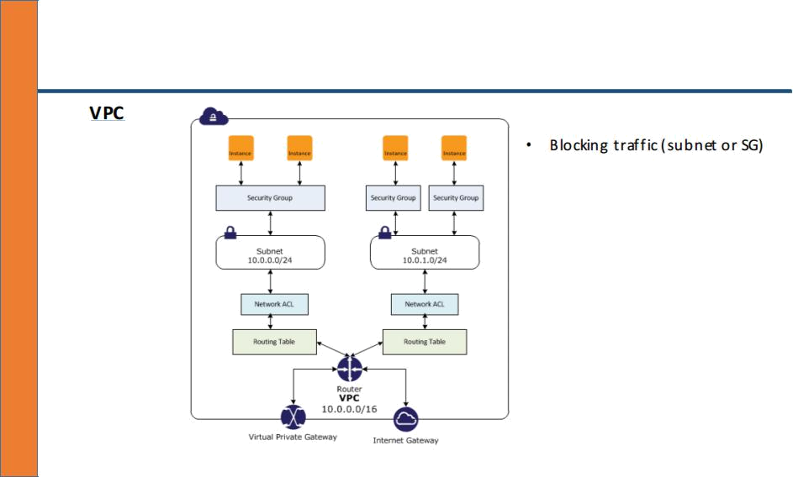

VPC Networking

VPC Networking

VPC Networking

- Each subnet must be associated with a route table

- By default all subnets traffic is allowed to each other available subnet within your VPC which is called the local route

- You cannot modify the local route

- Best practice is to leave the default route and create a new route table when new routes are needed for specific subnets

- Internet gateway provides NAT translation for instances that have a public IP addresses as signed (public IP to private IP)

- “To enable access to or from the internet for instances in a VPC subnet, you must attach an Internet gateway to your VPC, ensure that your subnet’s route table points to the Internet

Gateway, ensure that instances in your subnet have a public IP address or Elastic IP address, and ensure that your network access control and security group rules allow the relevant traffic to and from your instance” – AWS

NAT INSTANCE

- Instances launched into a private subnet can’t communicate with the internet. This is a higher level of security but it creates the limitation of the instance not being able to download software and software updates. In order to solve this issue you can create a NAT instance

- NAT instance

  - Must be created in a public subnet

  - Must be part of the private subnets route table

VPC Security

- Security Groups

  - Operate at the instance layer

  - Supports allow rules only

  - Is state full so return traffic requests are allowed regardless of rules

  - Evaluates all rules before deciding to allow traffic

- Network ACL

- Operates at the network/ subnet level

- Supports allow AND deny rules

- Stateless so return traffic must be allowed through an outbound rule

- Process rules in number order when deciding whether to allow traffic if it is denied at a lower rule number and allowed at a higher rule number the allow will be ignored and the traffic will be denied

- Applies at the network level s o it applies to all instances located inside of the subnet one deny will block all traffic on the port denied to all instances

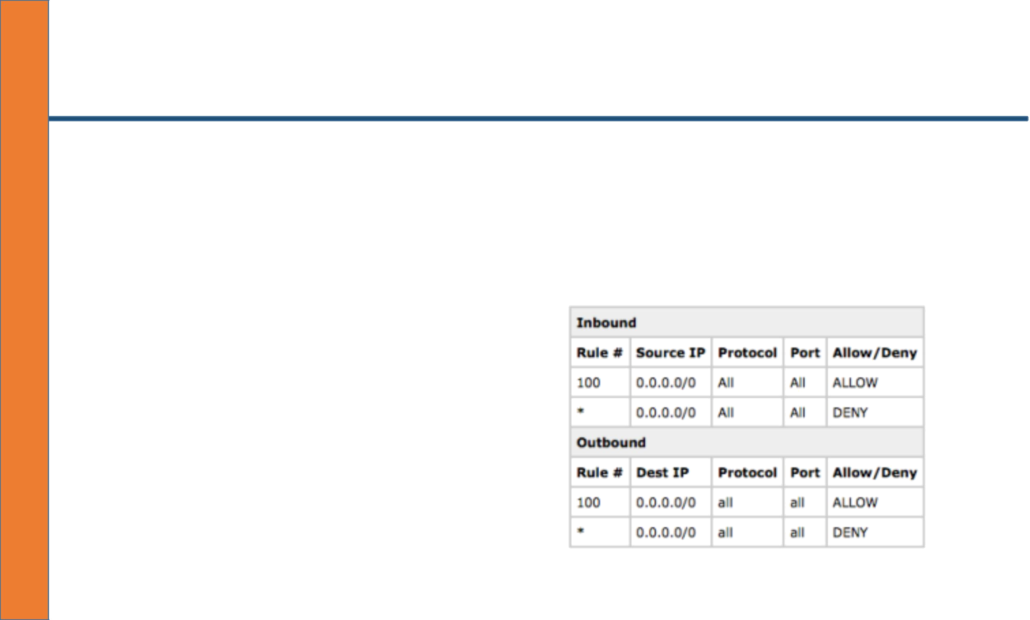
Network ACLS

- Network ACLs

- Process rules in order starting with the lowest number

- Deny all is the last rule (by default it is all denied) unless it is all allowed

- Best practice to increment numbers by 10 s o if you have to place in a rule in a certain order it does not create an issue

VPN/VPG Concept

VPN/VPG Concept

- VPN (Virtual Private Network): Virtual private network enables the ability to extend a subnet from one geographic location to another geographic location on two separate networks. Extending the subnets allows the network at location A to communicate internally with al resources at location B. This is essentially “extending” the on-premise network to the cloud or the cloud to the on-premise network. For AWS this allows us to communicate with all resources internally without the need for public/ private IP addresses or an internet gateway. This provides an additional level of security and ensures traffic to and from the VPN is encrypted

- VPG (Virtual Private Gateway): A Virtual Private Gateway acts as the “connector” on the VPC side of the VPN connection. The VPG is connected to the VPC and the VPN is associated with the customer gateway creating the endpoint.

- Customer Gateway: A customer gateway acts as the “connector” on the on-premise side of the VPN connection. This is where you configure the public IP address for the on-premise network.

- Note: Both a VPG and a Customer Gateway are required to establish a VPN connection.

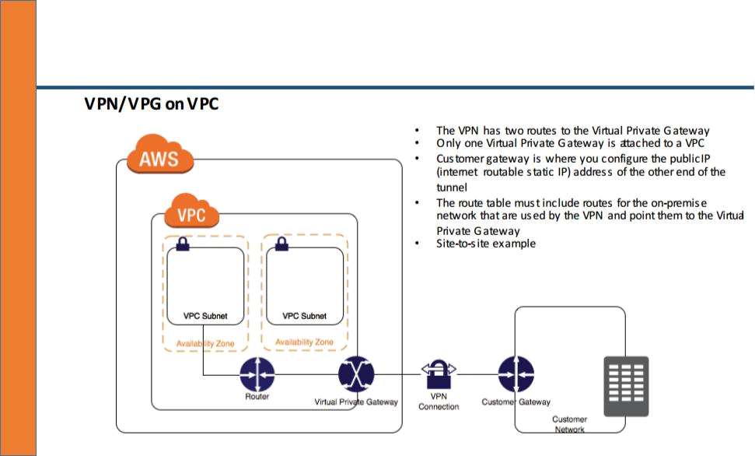
VPN/VPG Concept

Alternative Methods For Deploying A VPN to AWS

Alternative Methods For Deploying A VPN to AWS

- Configure an OpenVPN instance (Not site-to-site but a VPN tunnel)

  - Lives in a public subnet and you connect to the public IP using the OpenVPN client

  - The OpenVPN client from your machine receives a new IP address from the OpenVPN server

  - The IP only exists on the OpenVPN server but the VPN routes that IP address range to the subnets

  - OpenVPN instance use a route table that lives on the OpenVPN server that is able to route our private OpenVPN client users from the OpenVPN server to the AWS VPC address range Source: aws.amazon.com

- How to Apply High Availability To OpenVPN Single Instance

  - Perfect example of single instance “fail over”

  - OpenVPN has an elastic IP address

  - A backup OpenVPN instance is running in an alternative AZ

  - Script logic that determines if the OpenVPN is unavailable

  - If the OpenVPN instance is unavailable using a script and AWS CLI detach the Elastic IP and Reattach it to the backup instance



